Software engineering for big data analaysis

CSA-1035

EXP NO:- 13

1. Draw a Class diagram for Library Management System using CASE tools. Designing use case diagram for the library management system. User who registers himself as a new user initially is regarded as staff or student for the library system. Librarians have a key role in this system. Librarian adds the records in the library database about each student or user every time issuing the book or returning the book, or paying a fine. Design the class diagram for this

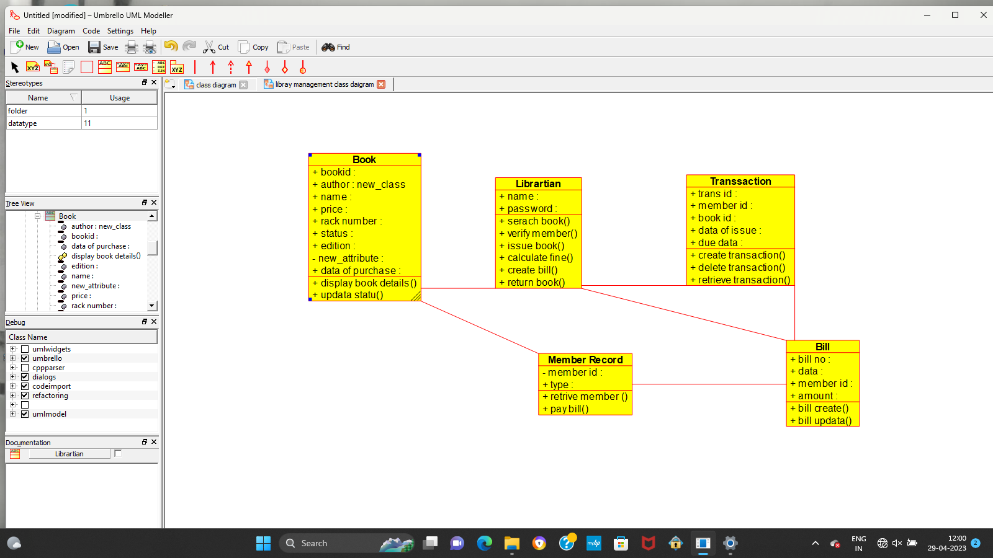

RESULT:-

Thus the class diagram for libray management is drawn and verified successfully